Traditional Classification VS NLP model
A normal ML model looks at your data all at once (like a one-hot vector — a bag of ingredients with no order). An LSTM reads the ingredients one at a time, in order, and remembers what it read before, so it can pick up on patterns like word order or nearby context.
Comparsion:
Component | Model A | Model B
Input | Ingredient list | Ingredient list
Encoding | One hot encoding | Sequence of word IDs-Embeddings
Model | Logistic Regression | LSTM
Output | Halal / Haram | Halal / Haram
Training Speed | Fast Training | Slow Training ,Because it has to process the sequence of tokens

Evaluation metrices :
- Model A :
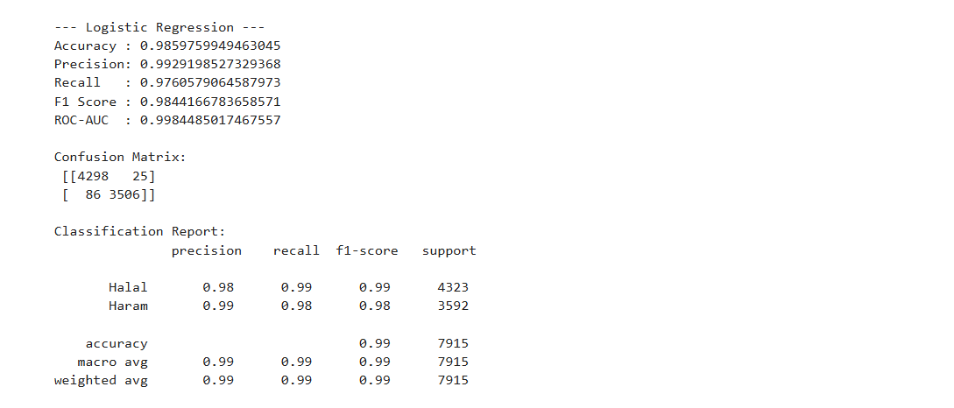
- Model B:
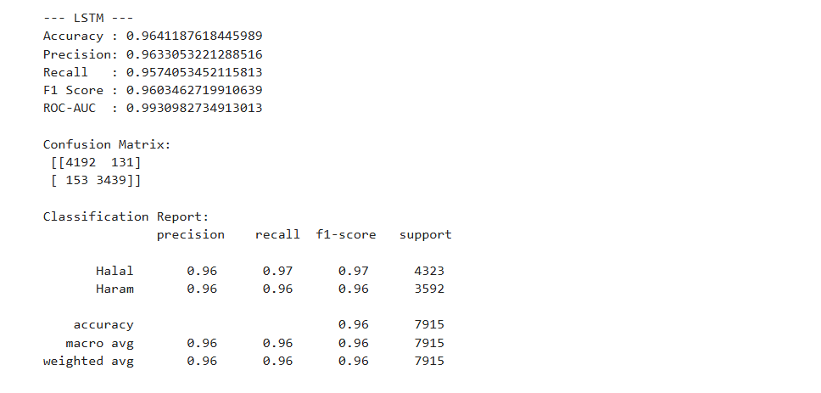
ERROR ANALYSIS:
# | Ingredient / Input | Expected | Model A Prediction | Model B Prediction
0 | chicken breast | 0 | 0 | 0
1 | olive oil | 0 | 0 | 0
2 | pork bacon | 1 | 1 | 1
3 | alcohol | 1 | 1 | 1
4 | gelatin | 1 | 1 | 1
5 | vanilla extract | 1 | 0 | 0
6 | lard substitute | 1 | 0 | 0
7 | wine vinegar | 1 | 1 | 1
8 | rennet | 1 | 0 | 0
9 | porkk | 1 | 0 | 0
10 | gelaitn | 1 | 0 | 0
11 | sugar, gelatin, salt | 1 | 1 | 1
12 | beef stock | 0 | 0 | 0
13 | halal chicken broth | 0 | 0 | 0
Analysis Results:
Both models fail on misspelled words ("porkk", "gelaitn")
Both models struggle with rare/ambiguous words ("rennet", "vanilla extract")
Conclusion:
- LSTM is a better choice because it understands word meaning and context while Logistic Regression will just see whether word is present or not. LSTM is the better model because it can capture deeper patterns.
Example:
Model B (LSTM) outperforms Model A on multi-word phrases like "lard substitute" shows that LSTM captures context/word combinations better than simple multi-hot encoding.

- Logistic Regression is getting better evaluation metrices here because it is good for keyword spotting and halal/haram classification is mostly keyword-based.

